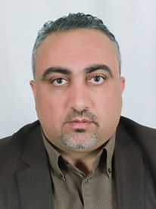
Dr. Mohammed Ali Rabae
Call No . 00972- 597934496
Email mohdali.1973@yahoo.com

Personal details
Birthday : 17/5/1973
Address: West bank / Hebron / Dura
Nationality : Palestinian
Marital Status : Married
Education and certifications:
- M.A degree in family's medicine from AL-Najah University -Palestine( 2014)
- B.A degree in medicine and surgery from Alma-ATA in Kazakhstan ( 1998)
- A degree of AL-TAWJIHI (High School) from AL-Hassan AL-Bassri – Jordan
workshops
- A training course in pediatric first-Aid (2000)
- A training course in first-Aid ( 2001)
- A workshop in NCDS (2010 )
- A workshop in diabetic care (2014)
- A workshop in TOT family's medicine ( 2014)
Professional experiment
- (1999-2008) work in Palestinian Red Crescent as G.P
- (2008 -2014) work in ministry of health ( MOH) as G.P
- ( 2008 -2010) work in AL-Wattani Hospital in Nablus city
- (2010-2014 ) work in Yatta Hospital in Yatta city
- (2014-2019) work in Primary Health Care ( PHC) as a family's medicine doctor
- (2016-2020) President of Palestinian Association of Family Medicine
- (2019) Acting Director of Heath Affairs
- (2020 ) Director of the National center Covid19
- (2020) Acting Director of the Dura center Covid19
- (2021-till now)_ General Director of Dura Government Hospital
Skills
- Have a driver license
- Computer skills ( word, excel, power point )
- Ability to communicate and communicate with others .
- Ability to manage meeting .
- The Ability to prepare Reports
languages
- Arabic native speakers
- Excellent communication skills in Russian language ( speaking, writing , listening and reading)
- Good communications skills in English ( speaking, writing , listening and reading)

